Student Community Name | Event Name | Event Date | Theme | Photos of Events
Environment and Young TEMA Community | Garbage Collection and Separation | 04 March 2019 | The Campus Garbage Collection event has been held continuously for four years to raise awareness. | 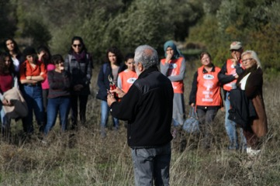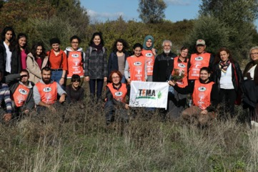
 | IZTECH collective nature work | 19 March 2019 | It is a nature-friendly campus project that aims to bring our students together with the most fertile lands of our campus. | 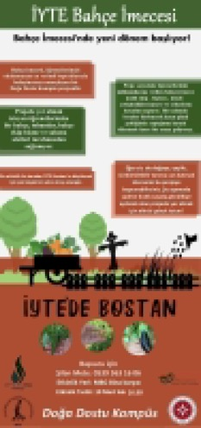
 | 11 Million Sapling Planting Event | 11 November 2019 | To contribute to the afforestation work on the burning forest area. | 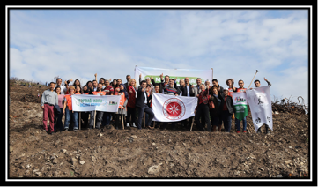
 | Seminar on Air Pollution and Forest Fires | 06 December 2019 | The event was organized by Young Tema Community and the collaboration of Atatürkist Thoughts  Community | 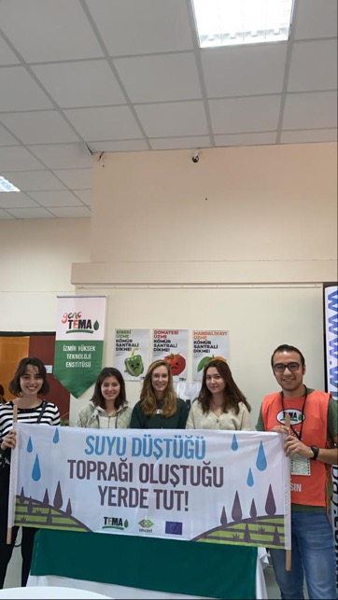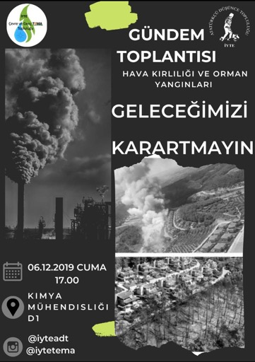
Community of Design |  |  | Making shapes with painted hands on the fountain in the campus festival area within the scope of March 8, International Women's Day.
 | There is a female hand on campus - 2 | 08 March 2019 |  | 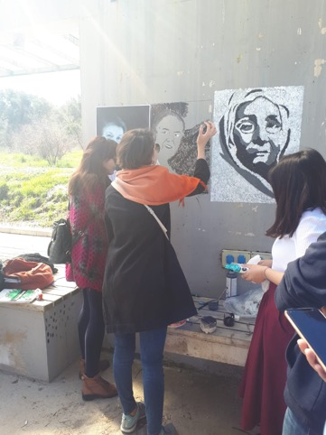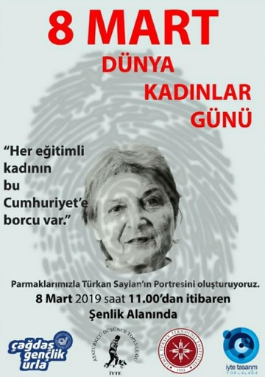
 | There is a female hand on campus - 3 | 09 March 2020 |  | 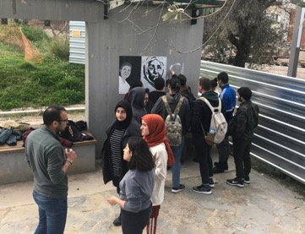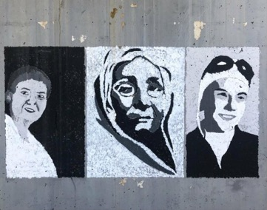
Cinema Community | The “Peninsula Cinema” Project For The Sustainability Of Social and Cultural Interaction | 2019-2020 Academic year  every two weeks | The idea was to bring our primary school friends, who study in a peninsula kilometers away from the Cinema Halls, to our Institute and host them at the campus with the project called “Peninsula Cinema”. With the movie The Little Prince, it was aimed that they descend into their imaginations and create new worlds with their creativity. | 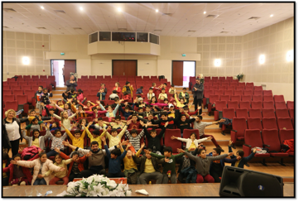
Association For Supporting Contemporary Life | “May your gift be a book” Campaign. Collection and donation of Books | Throughout the 2019-2020 Academic year | The books collected under the campaign will be donated to the libraries of schools in need. | 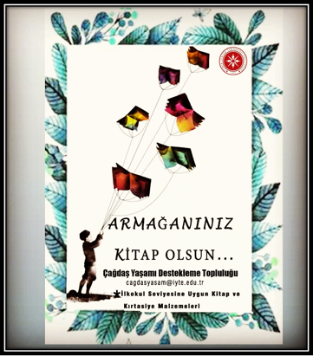
IEEE Community | Seminar on "The Significance of Women in Science and the Transfer of Experience" | 11 March 2019 | A seminar organized by the community and given by professors invited from other universities as part of 8 March International Women's Day
 | Competition “FuturEnergy’19” | 02 April 2019 | Energy-related student industry meeting
 | Conference on "Communication Sector and the Significance of Women in the Sector" | 05 April 2019 | The importance of women in engineering has been emphasized and a student-sector meeting was organized.
Folk Dance Community | Dance Show Within the Scope of "8 March International Women's Day" | 08 March 2019 | Music concert and dance shows on significant days | 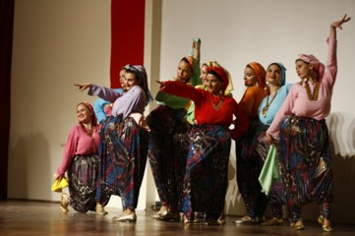
International Dances Community | Dance Show Within the Scope of "8 March International Women's Day" | 08 March 2019 |  | 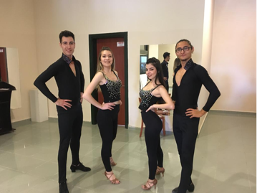
Music Community | Music Concert "Within the Scope of 8 March International Women's Day" to Emphasize Gender Equality | 08 March 2019 |  | 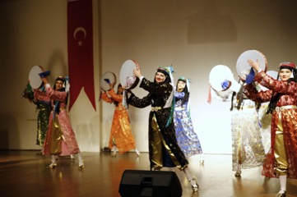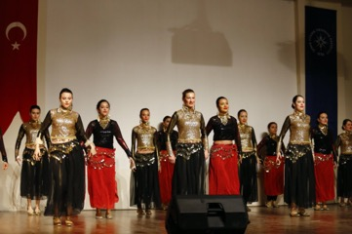
Thought Community | Seminar on "Elimination of Violence Against Women" | 27 November 2019 | As part of the “International day for the elimination of violence against women”, a conversation titled "Combating Violence Against Women" was held with lawyer Serap Emir. | 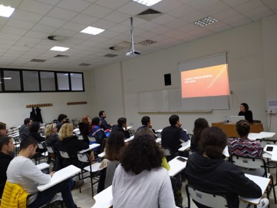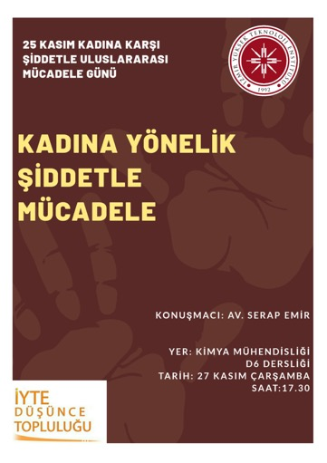
Atatürkist Thoughts  Community | Painting Exhibition within the Scope of International Women's Day | 04-08 March 2019
 |  |  | Events within the scope of 8 March International Women's Day
 | Meeting within the Scope of International Women's Day | 05 March 2019
 | There is a female hand on campus - 3 | 08 March 2019 | Making shapes with painted hands on the fountain in the campus festival area within the scope of March 8, International Women's Day.
 | Sustainability of education -General Meeting on Village Institutes | 02 April 2019 | Exchange of ideas with community members on the subject
Nature Research Community | Trekking to the Waterfall on the Campus to Explore the Nature | 23 February 2019 | Trekking and research
Innovation Community |  |  | "Renewable energy" and "sustainable innovation", which are the energy of our future and which are becoming widespread throughout our country, especially in İzmir, gain importance and meaning in the energy sector day by day. In today's world where energy needs and environmental problems are increasing, the spread of clean energy and directing the future is more than a breakthrough in the competition between countries. "Why renewable energy?" We tried to find an answer to the question. In this context, the significance of renewable energy in the energy sector and the importance of this energy was discussed. It was also aimed to ensure that the companies in the sector promote job opportunities for newly graduate engineers and scientists.
 | Seminar on “Sust’ıno” 2019- Renewable and Sustaimable Energy. | 10 December 2019 |  | 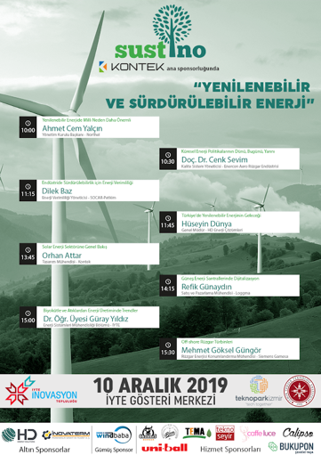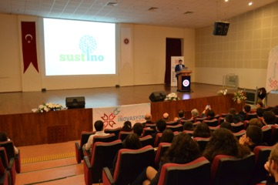
Anthropology Topluluğu | Interviews on "March 8, International Women's Day" | 08 March 2019 | An event with guests interviewees on the importance of women
Permaculture and Ecological Life Community | Seminar on "Local Seeds and Healthy Food" | 26 February 2019 | - To bring together advantageous and disadvantaged segments of the society from different ages, cities, countries and ethnic backgrounds within the framework of sustainability principle in order to contribute them to the production process.  - To ensure that the non-functional areas of the institution's gardens are transformed into effective areas by greening.  -To explain the importance of using and preserving local-ancestral seeds.  - Ensuring that organic wastes from schools, domestic and institutions dining halls are converted into soil by forming compost. | 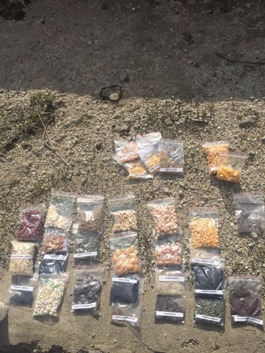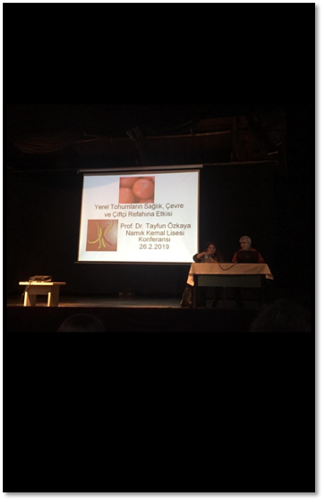
 | Recycling container building workshop with waste pet bottles | 31 February 2019 | The aim of event was to draw attention to the disposable plastic water bottles that are widely used in the School of Foreign Languages and to help reduce their consumption. And by that, raising the awareness of students to reduce the consumption of disposable bottles. | 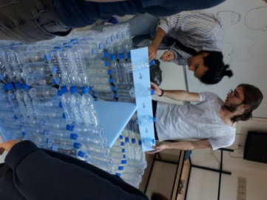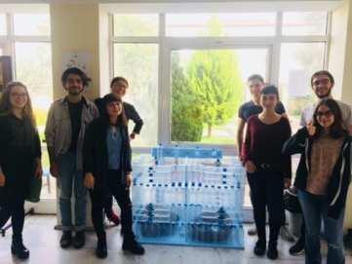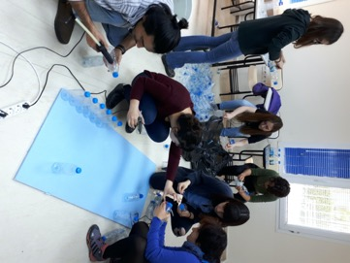
 | Summer Garden Seed Planting Event (İyte Young TEMA, İyte Atatürkist Thought and Iyte Permaculture Community) | 19 Mart 2019 | The event aimed to make the necessary arrangements in order to prepare the IZTECH Garden for the summer and to plan the local heirloom seeds. | 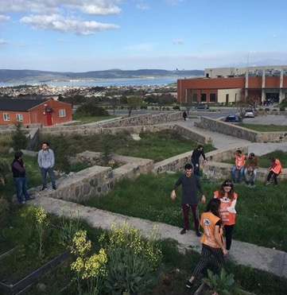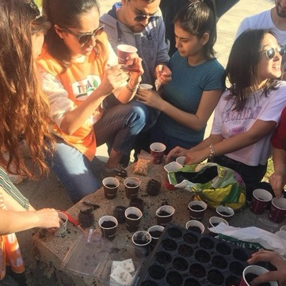
 | Swap (Conscious consumption) activity | 17 April 2019 | • To make İZTECH students review their consumption habits.  • To spread the culture of cooperation and collective work in the IZTECH campus.  • To raise the awareness of students about the steps to be taken to reduce our carbon footprint.  • To show that we can meet our needs without inciting the consumption craze.  • To show that we do not have to spend money to have a good time and that we can revive the IZTECH campus together. | 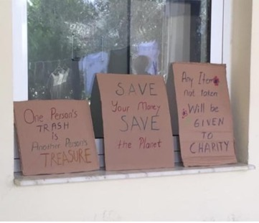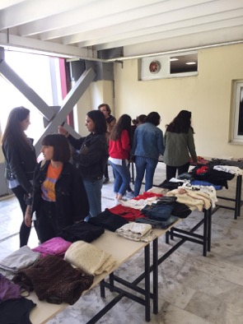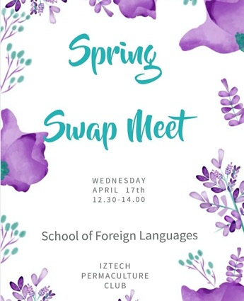
 | Monday Meeting Events | Every Monday | • Maintenance of IZTECH Garden.  • Maintaining the compost area prepared for the conversion of organic wastes in the garden to soil.  • Preparing and eating food with vegetables grown in the garden in order to bring community members together and integrate them. | 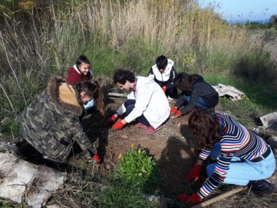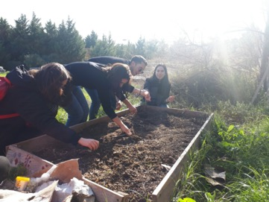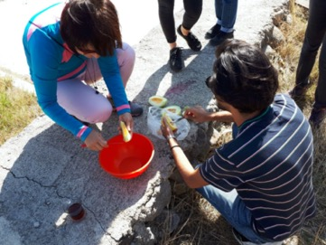
Volleyball Community | Book Donation Campaign for Sustainability Of Education | 03 June 2019 | In order to transform the Urla High School library into a regular and encouraging library environment, we first visited the library and determined what needs to be done, and then started a book donation campaign for the library at our Institute. Thanks to the help of our students, we enriched the high school library with various books. | 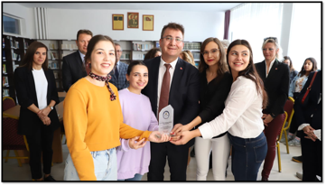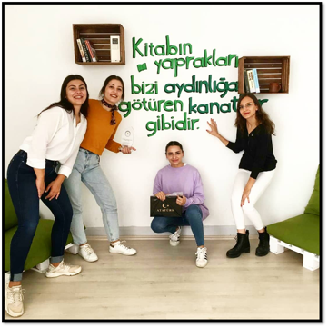
Turkish World Research Community | Painting Exhibition on "International Women's Day" | 08-15 March 2019 | Events within the scope of 8 March International Women's Day
 | The City Library Project For Sustainability of Education | 16 December 2019 | Keeping the names of the martyrs alive with donated books and providing book support to those in need.
Outdoor Sports and Mountaineering Community | Nif Hill Summit | 04 January 2020 | A hiking activity to the hill in Kaynaklar Village in Buca in order to create awareness about our close environment.
Environment and Young TEMA Community | Campus Cleaning Event | 07 January 2020 | Campus garbage collection activity that is organized to raise awareness about the environment. | 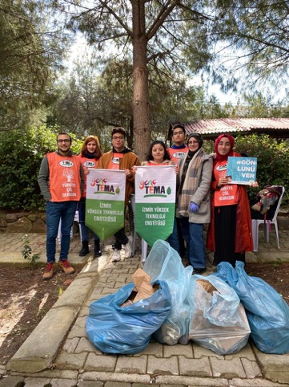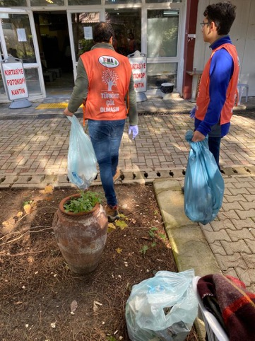
Environment and Young TEMA Community | Mastic Tree Planting and Care Event | 04 March 2020 | It is a nature-friendly campus project that aims to bring our students together with the most fertile lands of our campus. | 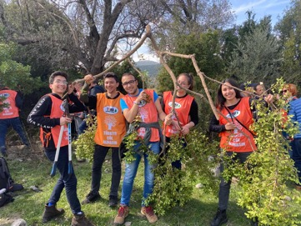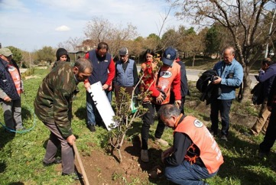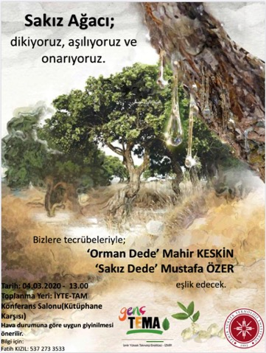
Athletics Community | Run For Cancer Awareness | 22 October 2019 | While organizing the awareness run, we aimed to draw attention to the increase in the incidence of breast cancer today and the importance of early treatment. Before the awareness run, our Molecular Genetics and Biology department students gave brief information about breast cancer, early diagnosis and treatment methods. With the Breast Cancer Awareness Run that we held after the briefing, we were able to take the level of awareness on the subject one step further in our Institution. | 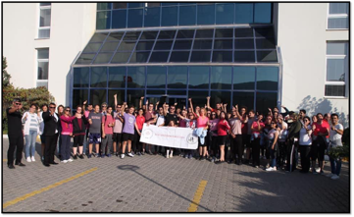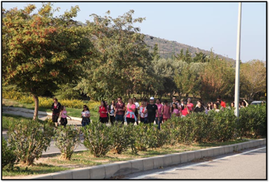
 | “International Women's Day Run” Event | 11 March 2020 | Events within the scope of 8 March International Women's Day
Design Community | Clothing Aid Campaign | 28 March 2021 | It is the activity of providing school equipment to the students in the primary school of Kızılkeçeli village in Bayındır, İzmir, and also providing clothing donations to students and families in need. | 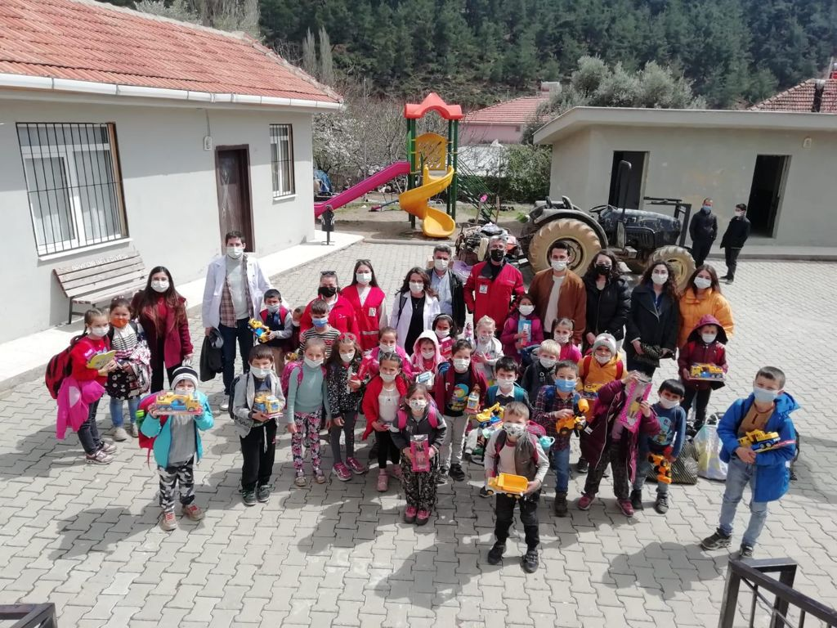
Building Community | Clean Environment, Healthy Life Event | 30 March 2021 | With the project, certain areas have been cleaned with our community members, and the community planned to repeat the project in the future. | 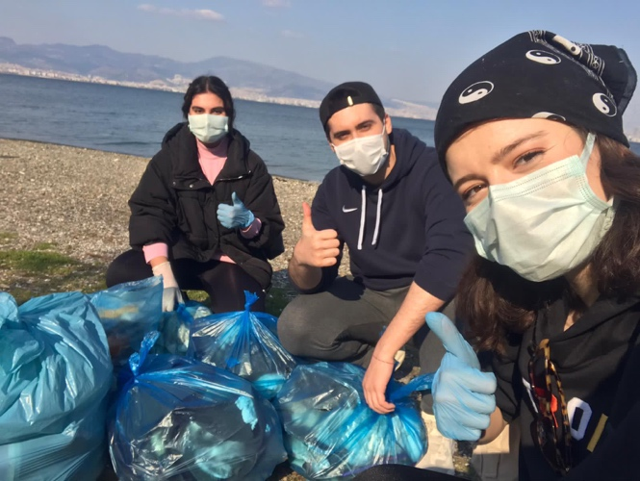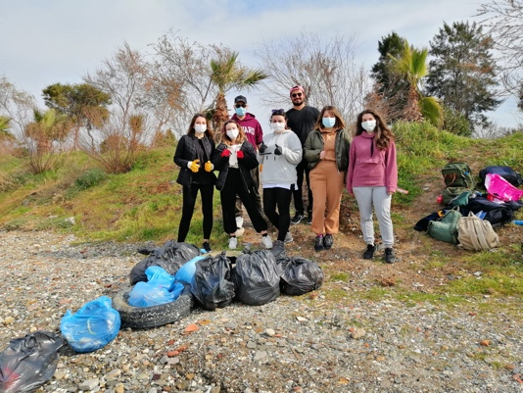
İztech MUN Community | Interview with “Ece Soyer Demir, Vice Chairman of the Association for Combating SMA Disease” | 29 April 2021 | A live broadcast was made on the community's Instagram account (iztechmun), where we hosted Ece Soyer Demir, Vice Chairman of the Association for Combating SMA Disease. Through this publication, we have created an awareness on this issue by discussing the unknowns and curiosities about SMA disease.
Building Community | K'iyap Project (Urla Şehit Kemal Primary School) | 4 July 2021 | About 350 books have been collected for the "K'iyap Project" and are stored in the community room and were donated to the school by hand at the beginning of the term.
Ecomotion Community | Online panel on “Zero pollution and environmental crimes” | 2-3 June 2021 | The panel topic, partnered with European Commision, SDG Student Hub, and İKÇÜ Uİ Community, was “What can youth do for green change?” | 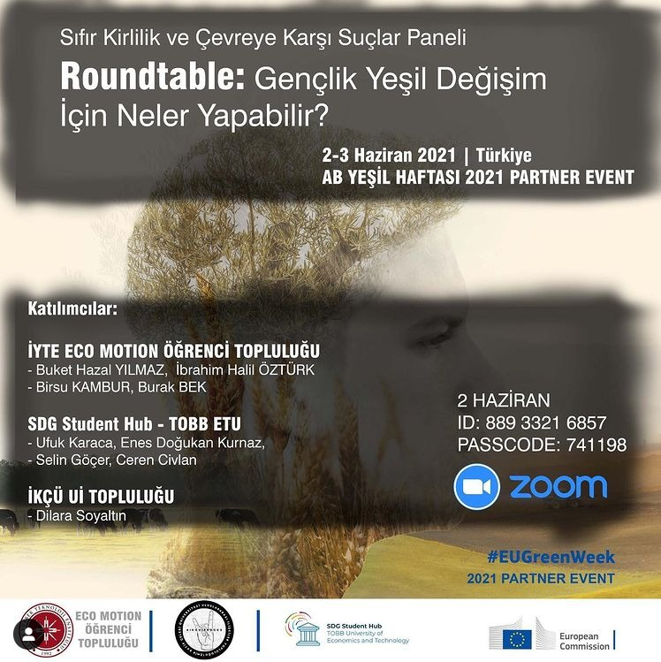
 | Karşıyaka Idle Land Workshop | 30 November 2021 | The field trip workshop for the identification and mapping of Karşıyaka idle lands was organized in cooperation with IZYECH Environment Community and Young TEMA society. | 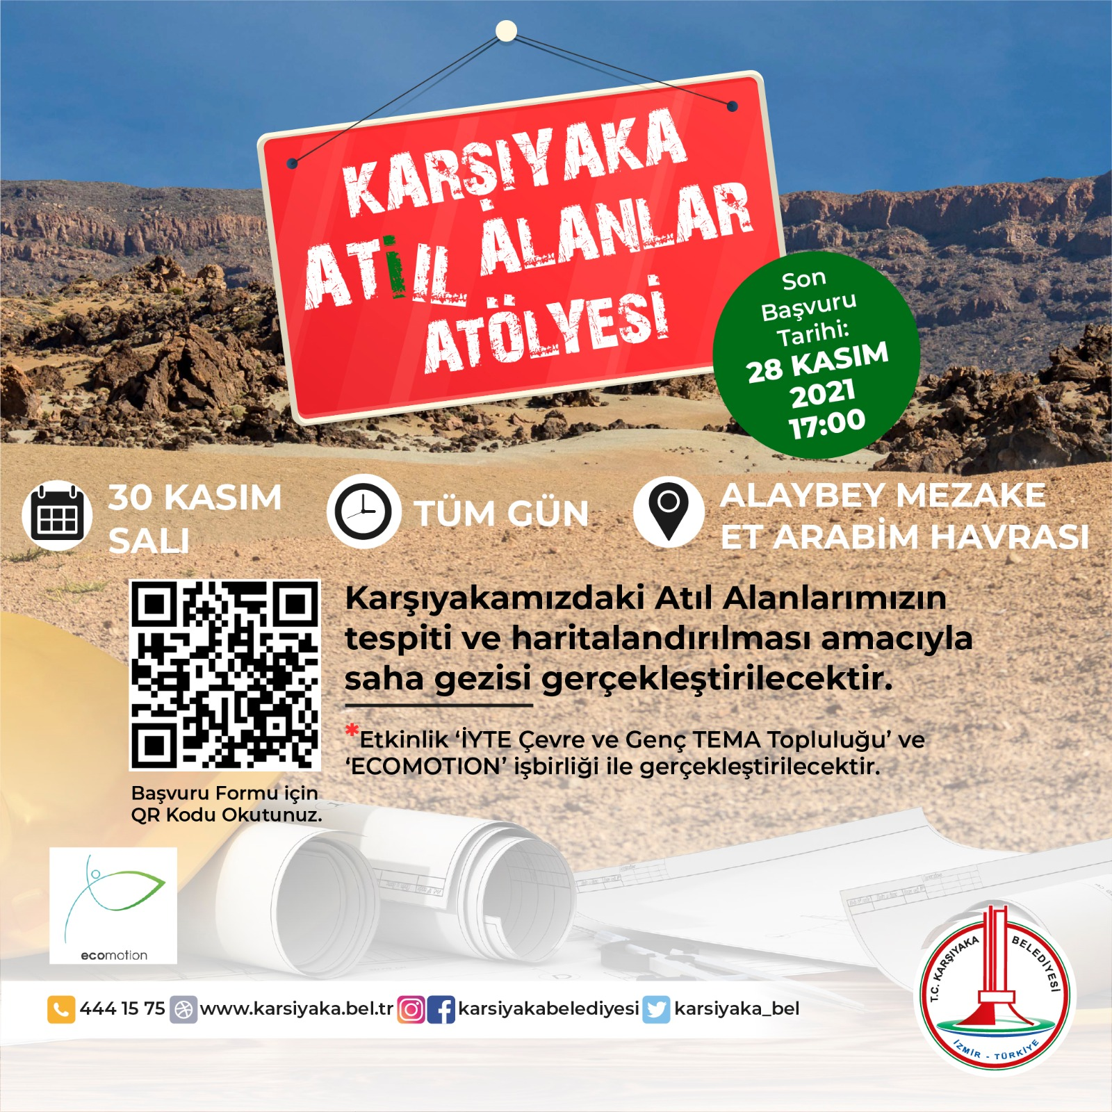  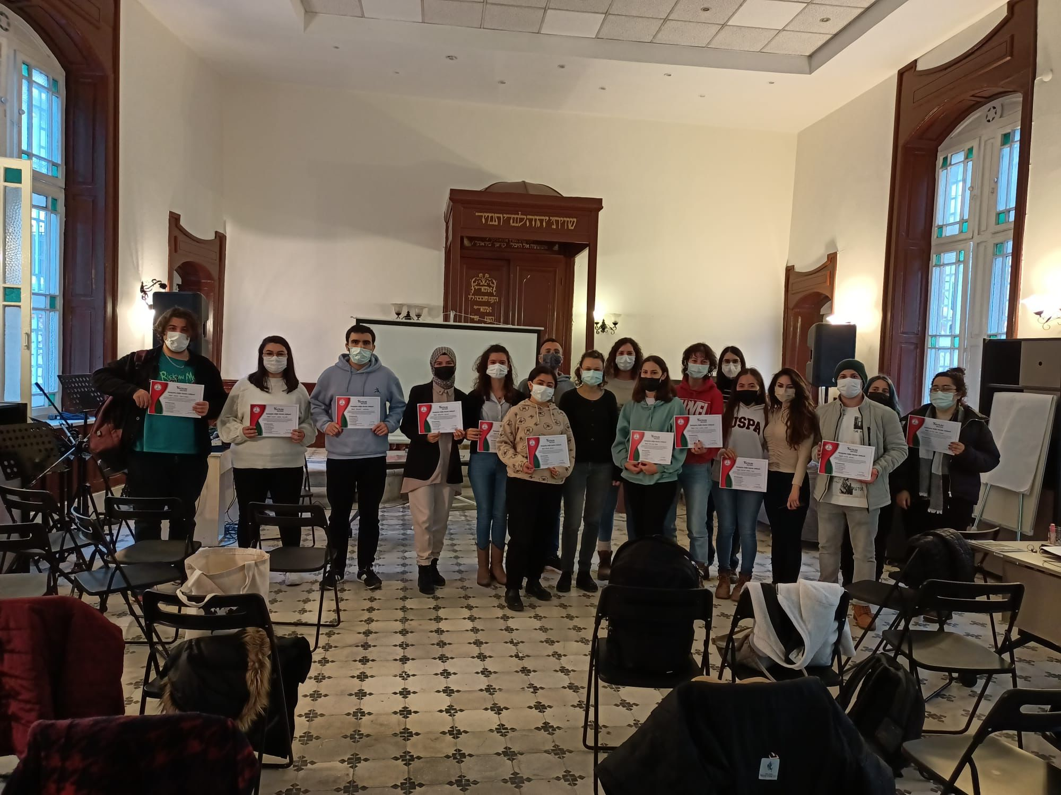
 | Compost workshop in the Fculty of Architecture | 26 November 2021 | Associate Professor. Zeynep Durmuş ARSLAN talked about compost types, suitable soil types and it was aimed to learn compost making theoretically and practically. | 